WIN10 Enrollment

* Go to: [http://win10.pg.com](http://win10.pg.com/)

[http://win10.pg.com](http://win10.pg.com/) (*Default Screen*)

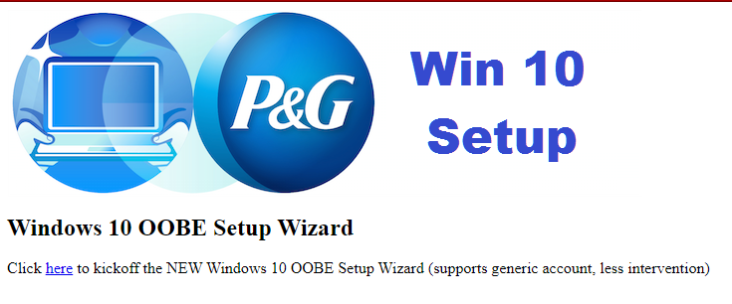

***To install Beta / AOT Version of script click on Picture:***

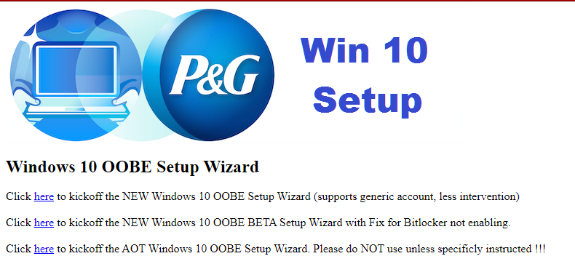

**Windows 10 Enrollment (Script types)**

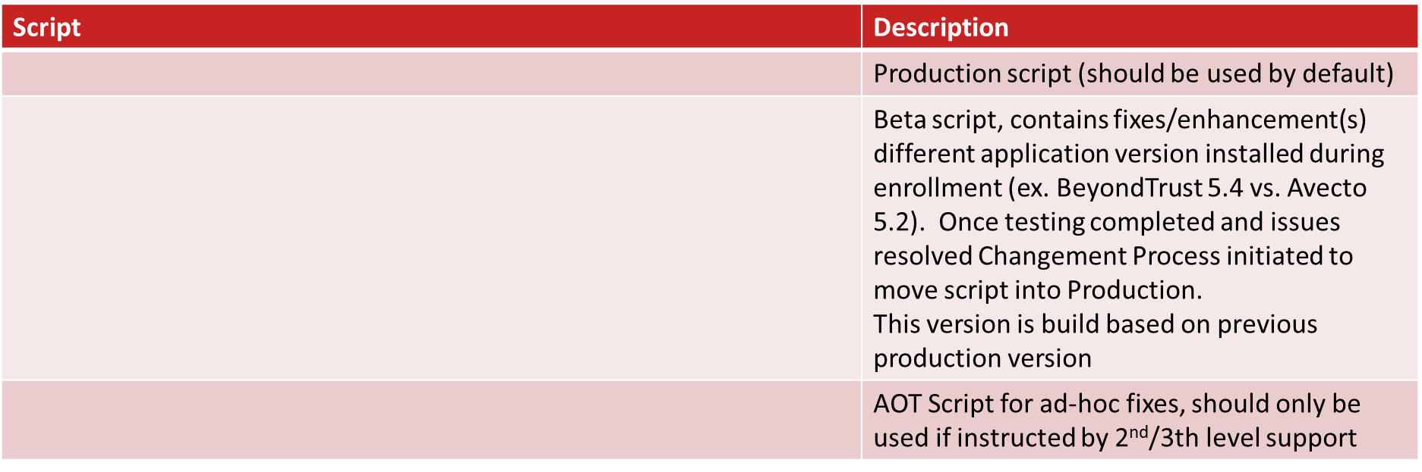

**Windows 10 Enrollment (release notes)**

|  |  |
| --- | --- |
| **Script** | **Description** |
| Version 2.0.3 (July 2019) - PRODUCTION | Fully automated end2end with auto-login  Support generic accounts  Streamlining overall process  Marimba Tuner supporting Peer 2 Peer |
| Version 2.0.3 – 2.0.6 (BETA) | Updated KMS Server (Cloud)  Updated WebService for inventory (Cloud)  Install BeyondTrust 5.4 (Beta)  Set BeyondTrust policy retrieval to 5’  Fix for .NET 3.5 installation (/NoRestart) |

WIN10 Enrollment

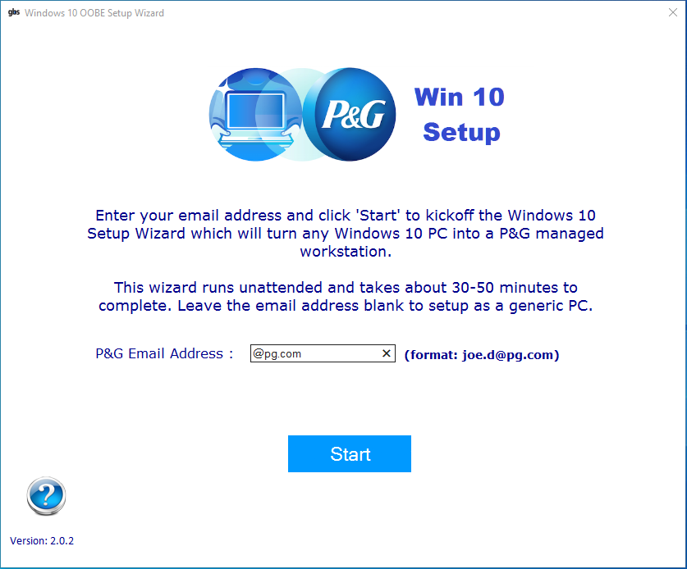

1. OOBE process is completed
2. **Launch the Enrollment wizard**
3. **Enter P&G user name or leave blank**

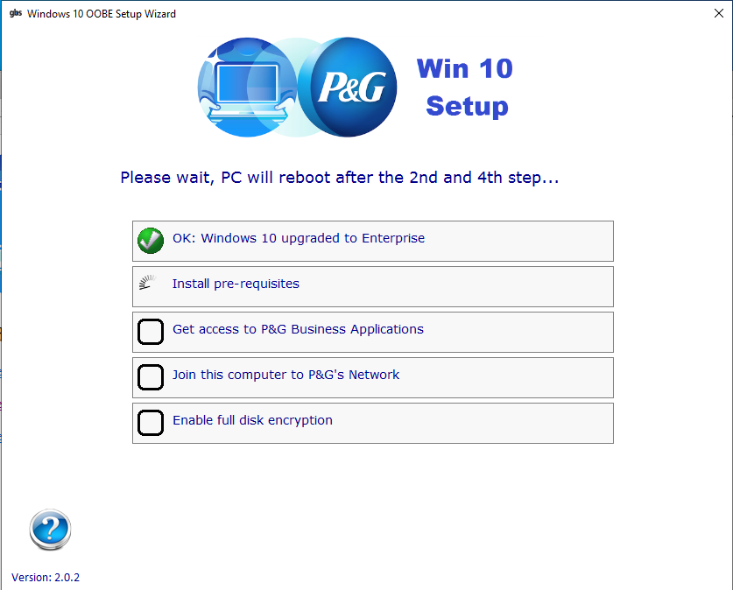

1. Download the migration script
2. Launch the Enrollment wizard
   1. Enter P&G user name or leave blank
   2. **Upgrade to Win10 Enterprise**
3. 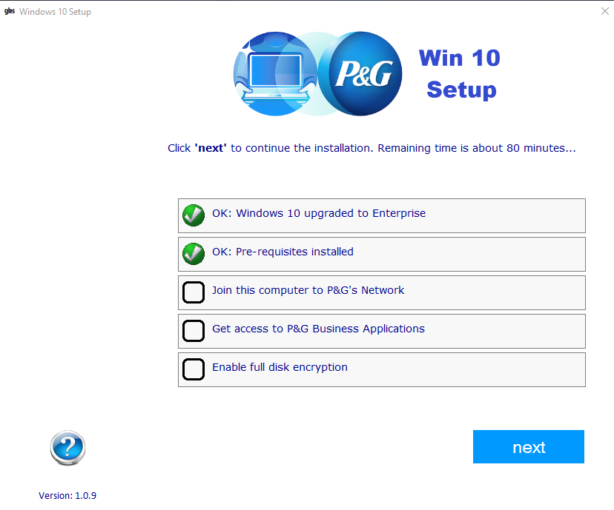Download the migration script
4. Launch the Enrollment wizard
   1. Enter P&G user name or leave blank
   2. Upgrade to Win10 Enterprise
   3. **Install pre-requisites**

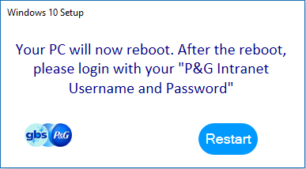

1. Download the migration script
2. Launch the Enrollment wizard
   1. Enter P&G user name or leave blank
   2. Upgrade to Win10 Enterprise
   3. Install pre-requisites
   4. **Join the PC to P&G domain**
3. 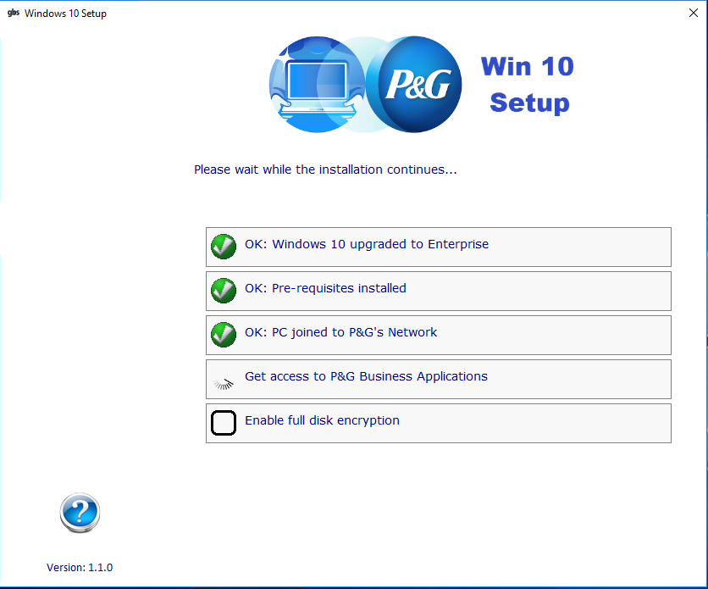Download the migration script
4. Launch the Enrollment wizard
   1. Enter P&G user name or leave blank
   2. Upgrade to Win10 Enterprise
   3. Install pre-requisites
   4. Join the PC to P&G domain
   5. **Install P&G business applications**
5. Download the migration script

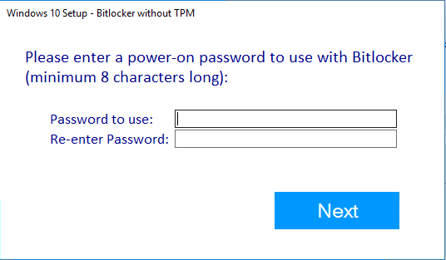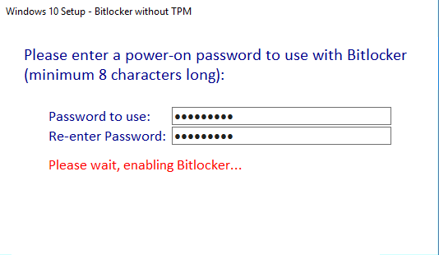

1. Launch the Enrollment wizard
   1. Indicate the P&G user account
   2. Upgrade to Win10 Enterprise
   3. Install pre-requisites
   4. Join the PC to P&G domain
   5. Install the P&G business applications
   6. **Enable BitLocker**

Windows 10 Enrollment v2.x

* Full Automated end 2 end once you click start
* Support for generic account
* Auto-login enabled
* Office 365 Pro Plus By default installed (P&G decision)

Checklist

* Joined to the domain
* Computer name conform to P&G naming standard
* Marimba client installed
* GM applications installed
* Local user accounts removed from local admin group
* Administrator account disabled
* User = User

Troubleshooting

* If you encounter any issues during the enrollment, logs can be found at:

Windows 10 Enrollment Logs

* + C:\HP\Logs\Win10PostSetup.log

**Marimba Logs**

- C:\Program Files\Marimba\.marimba\workspace\history-Yyyyy-Www.log